Blog Website

A PROJECT REPORT

BACHELOR OF SCIENCE

(Computer Science)

SUBMITTED BY

KATTOJU JAYASRI

Team LTVIP2023TMID08378

Sri Vivekananda Degree College

(Recognised by SRI VIVEKANANDA DEGREE COLLEGE, KASIMKOTA, VISHAKAPATNAM, ANDHRAPRADESH, INDIA.

# INTRODUCTION

Blog is a type of Website updated regularly with new content. A blog is just a space on the web that we can create to record and express our opinions, experiences and interests. This project comprises of two files. First is an HTML file for creating markup of the application on the web. Then CSS file is used to provide more styles to the website.

DECLARATION:

This is to verify that project report entitled "Blog Website”

submitted by me. I have done this project on the concept of

food. I hereby declare that the above particulars of

facts and information stated are true, correct and complete

to the best of my belief and knowledge. I comprises only my original work and due acknowledgement has been in the text to all other material.

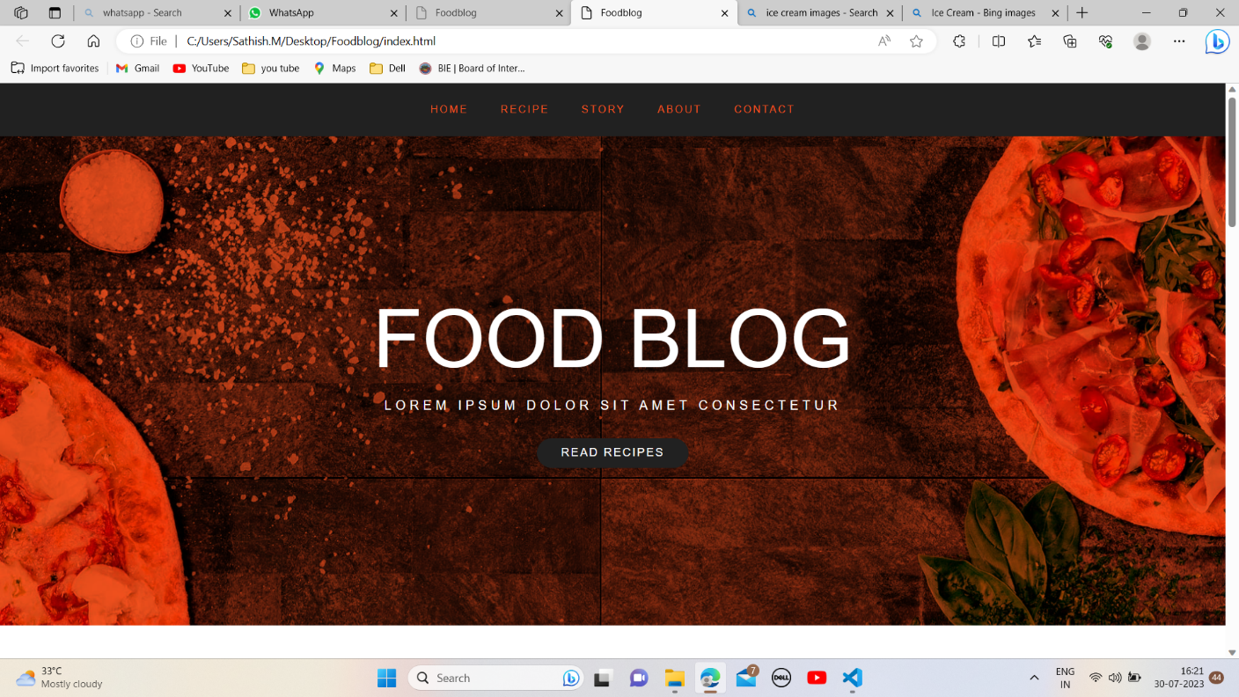

# SOFTWARE USED

Code Editor I used for this project is VS Code, It is used to code complex piece of programs and to develop complex projects. Further technologies I used for this project are HTMLS, CSS.

2.1 HTML5

It is the code for creating web pages, using tags and other commands that a browser

rends and web pages that people see.

2.2 CSS:

CSS is the language for describing the presentation of Web pages, including colours, layout, and fonts.

Result / Output

Home Section:

It displays about the food blog. In this, describe about the tastyfoods where the customers has visited. It shows to select the food what you have to want to taste it.



Food Section:

It displays a quick introduction about the food which are more tasty . In this section we have given three meals.

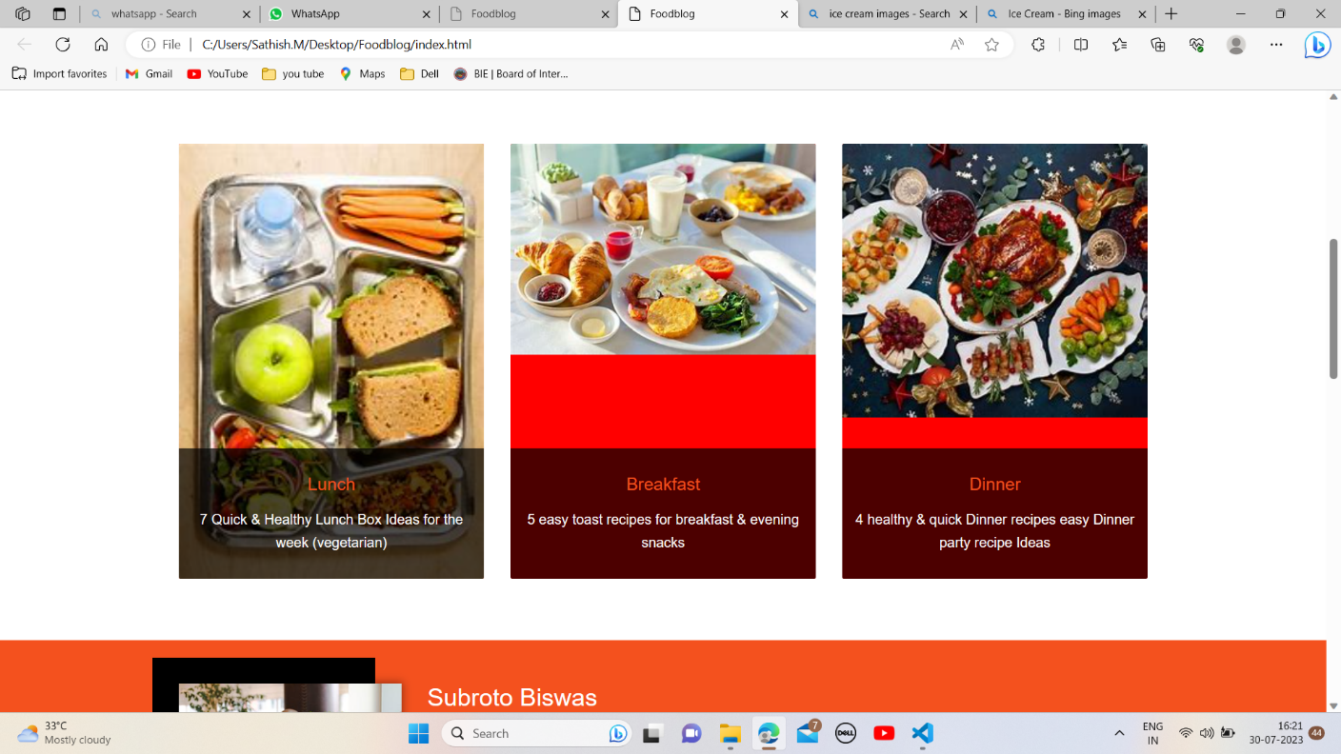

About Section:

Restaurants with strong branding—including their logo, images, and "voice" or writing style—often have strong customer loyalty. Customers want to learn about your restaurant and feel connected to your story. And customers who are connected are more likely to come back.

Trampel has noticed that customers are more likely to try a restaurant again after one "bad" meal if they have an attachment to the restaurant.

Extra Section:

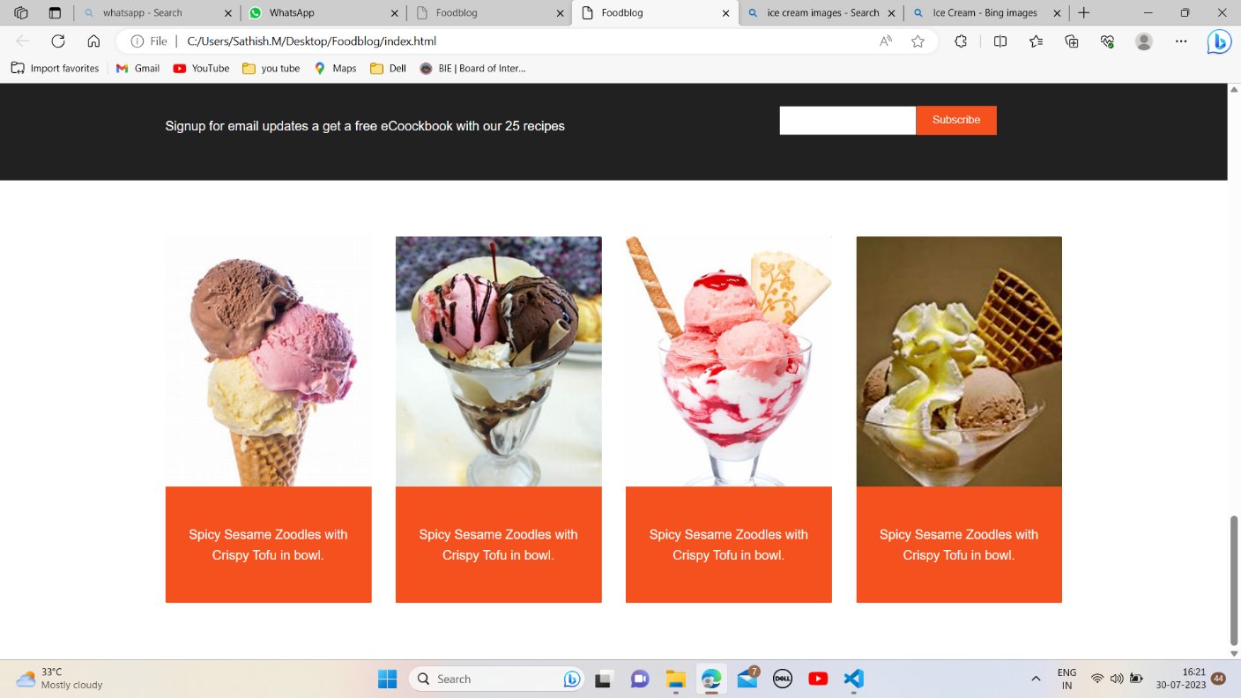

In this section, we have given some more foods which are more delicious.

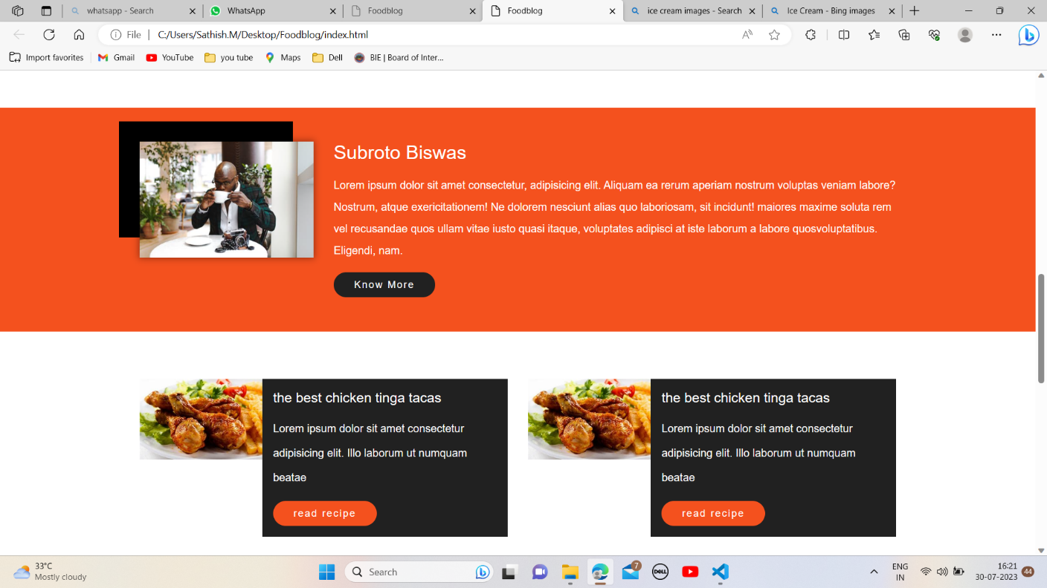

Subscribe Section:

In this section, there is a subscribe part. And there is a option to get updates through mails.

ADVANTAGES AND DISADVANTAGES ADVANTAGES: Reflects your personality and creativity. An online is an excellent refelection of who you are as a person and

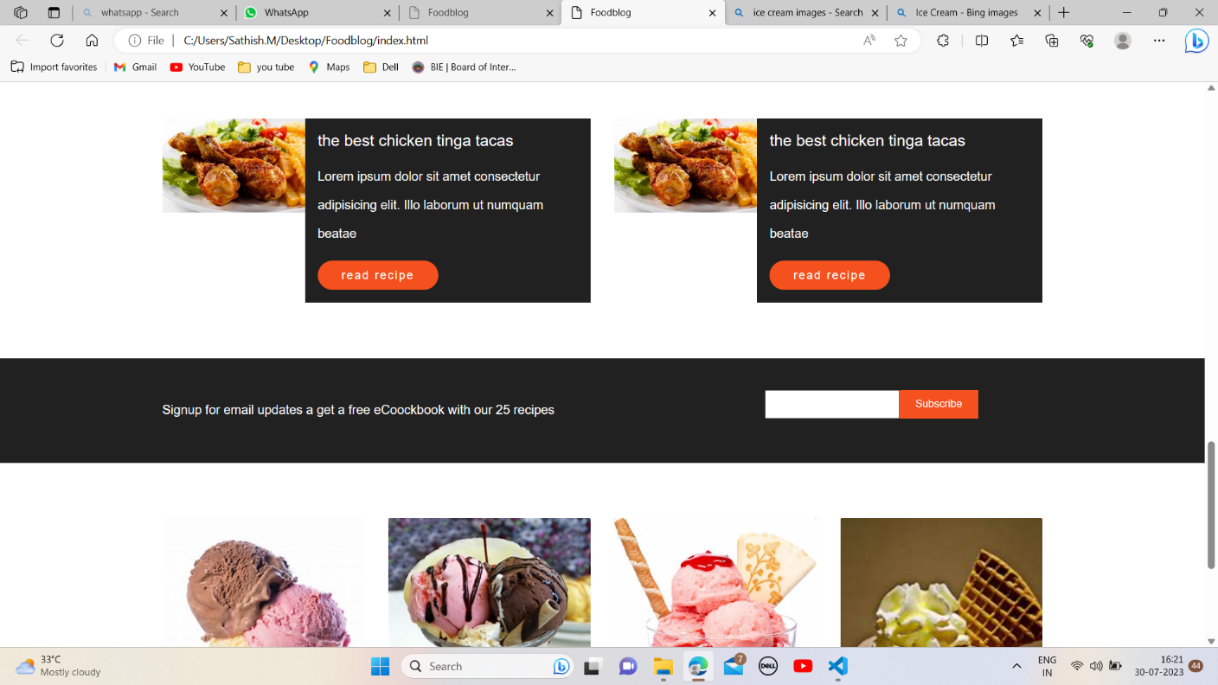

professional. You can choose how it present yourself, what achivements to list, etc. Again, design and layout are essential here.

* DISADVANTAGES: Faculty time requried to prepare the blog assingment and assist students as they prepare them. Logistics are challenging. Students must retain and compile their own work, usually outside of class. Motivating students to take the blog seriously may be difficult.
* Applications:

Linking google drive files like my images and my documents.

Spacing out the elements properly using CSS.

Choosing background was a major challenge as is had to be formal.

Conclusion;

At last to conclude, I have developed a simple and basic blog using HTML 5, CSS, JAVASCRIPT using VS Code as IDE which I would continue to maintain in future too,

Future Scope:

The scope of a standand blog is defined by it's component projects and programmes where as the scope of a structured portfolio is defined by the strategic objecåves it is designed to achieve.